Time Table Generation Tool:

Simple data required from user to generate the time table such as Class Capacity and Lecture Capacity.

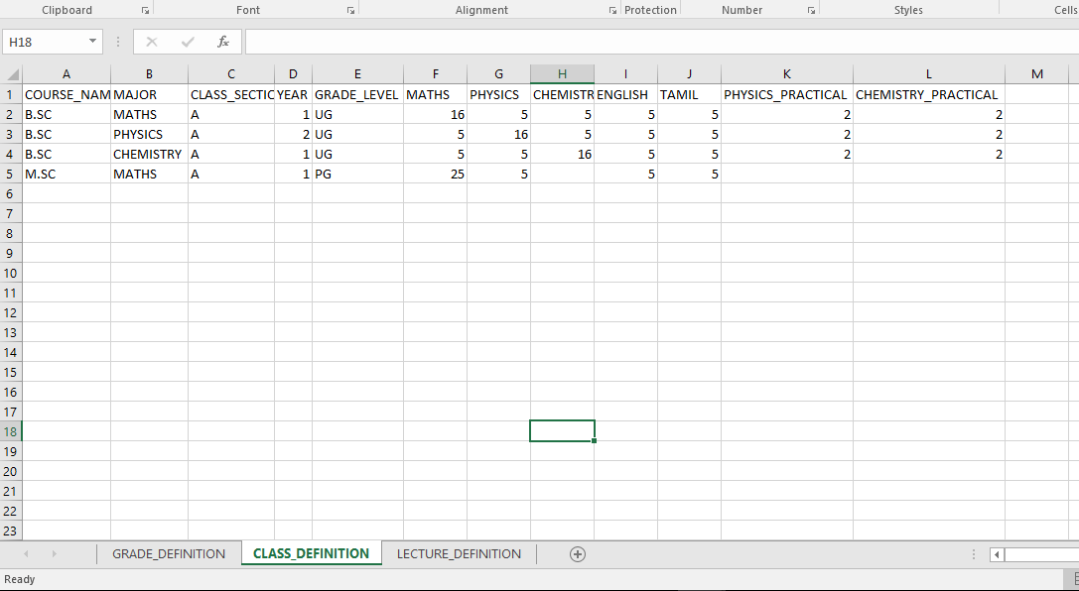

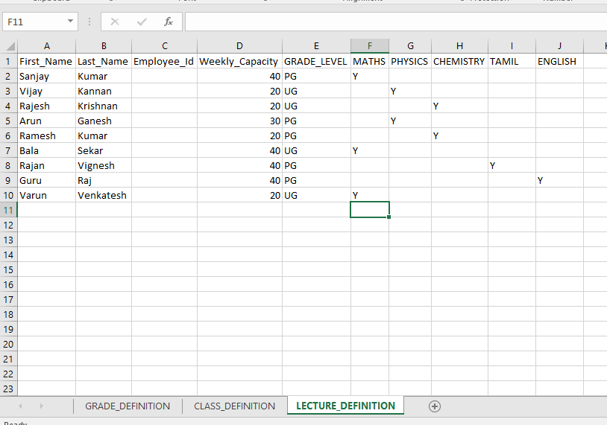

User has to just upload this data via choose file button and then when they click Generate Report button, the tool will smartly determine the subject allocations across classes and pick the capable lectures without making them over burden and/or clash with the other classes in the same day and hour.

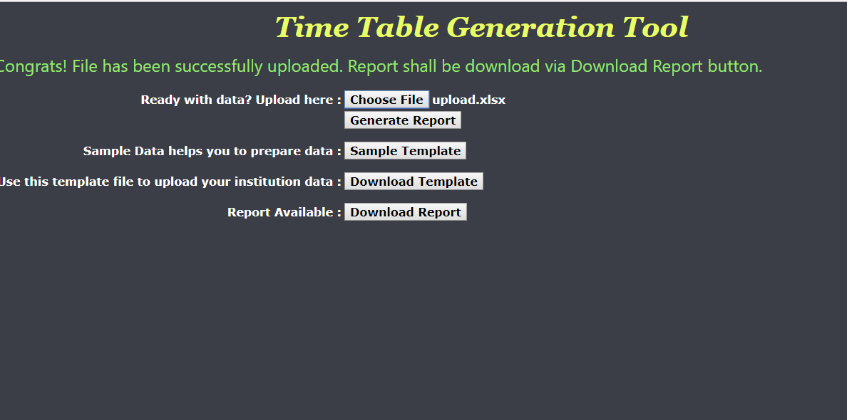

Once the report is generated successfully, the Download Report button will appear in the screen. User will be able to download the report just by clicking the Download Report button.

Output will be generated in the clean format and each subject’s time table will be provided in the separate sheets with the sheet name representing the course name as follows.

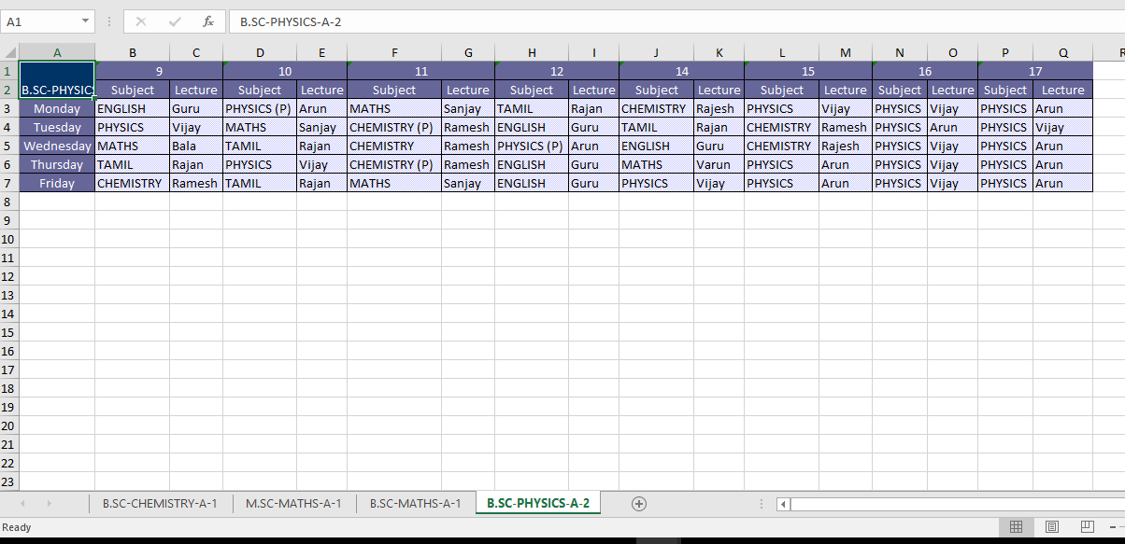

For making the quickest way to provide the input, user can download the sample input file template via Download Template button.

There is also an instruction / help on how to populate the input data, there will be a button with the name Sample Template presented in the tool.